Chapter 1 - DATABASES

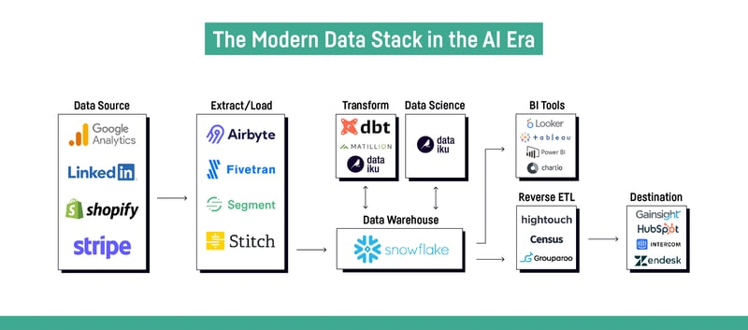

What is a Database?

1. SQL Databases
2. OLTP: Relational Database

* Used for transaction focused tasks, retail applications, CRM
* Row based storage
* Data is structured
* Optimized for insert and update operations
* Required to be available 24/7
* Straightforward queries which return small number of rows
* Highly normalized with many tables
* Minimize data redundancies (no duplicate data)
* Optimized for data collection not for aggregations
* Should not be used for reporting
* OLTP systems are ACID compliant
  + Strong consistency ensuring integrity of the transactions
  + One transaction needs to be successful before another one begins

1. OLAP: Online Analytical Processing

* Efficiently process big data
* Answer analytical queries
* Building blocks of Business Intelligence tools
* Columnar based
* Only needs to read in relevant data
* Data derived from OLTP databases (plus third-party sources)
* Copy of transaction data
* De-normalized with fewer tables (Facts & Dimensions)
* Queries usually have less joins to increase performance and speed
* Insert & Update speed is less important
* Complex aggregations

OLTP vs OLAP Summary (Recreate table)

1. NoSQL Databases
2. “Not Only” SQL

* Non-relational database
* Able to handle different types of data other than RDBMS
* Designed to handle large volume of distributed data
* Suitable for use-cases where fast horizontal scaling is important
* Appropriate for unstructured and semi-structured data
* Usually has simpler schema
* Goal is NoSQL not to replace SQL but to work together
* Many types of NoSQL databases exist for different use cases

1. Key Value Stores

* Simple, only stores key-value pairs
* Retrieves values by associated keys
* Suitable when speed is of most important
* Data is not complex
* Use cases
  + Shopping cart
  + Storing user sessions
  + Game session management
  + API reply stored in cache
  + Product recommendation

1. Document Stores

* Non-relational database designed to store and query JSON-like documents
* Stores each record and data within a single document
* No requirement to create a schema before you load data
* Can scale horizontally very well via sharding
* Common: JSON documents
* Use cases
  + Catalogs
  + Web applications / Ecommerce
  + IoT
  + Realtime Analytics

1. Wide Columns

* Stores data in flexible columns instead of rows
* Highly scalable and able to handle ambiguous and complex data types
* Names and format of the columns can vary across rows in same table
* Not optimized for joins should not be used for:
  + If database requirement changes frequently
  + Ad-hoc query patterns
  + High level of aggregation
* Use cases
  + Real time data / Analytics
  + Time Series
  + Trading data
  + IoT

1. Graph Databases

* Purpose built database to store and navigate relationships
* Relationships are first-class citizens and it is stored alongside the data in the model
* Data entities are stored in nodes, relationships are stored in edges, information associated to nodes are properties
* Queries are very fast due to relationships not being calculated during query time instead it is stored in the database
* Use cases
  + Recommendation Engines
  + Fraud Detection
  + Social Networks
  + Logistics
  + Metadata Management
  + Natural Language Processing

1. Search Engine Databases

* Database dedicated to search of data in form of web search or full-text search
* Data is stored in JSON document form and is schema-less
* Uses indexes to categorize the similar characteristics among data
* Solves searching of textual content in databases by allowing natural language search
* Use cases
  + Full-text search
  + Time Series Data
  + Logging and Analysis
  + Auto Suggestion / Auto Completing